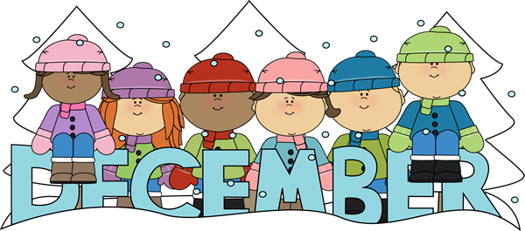

English Language Arts  Reading  This month we our classes will launch an interpretation book club unit. In this unit we will revisit some of the work we have done in our first fiction unit such as character traits, motivations, feelings, and theme.  **Please make sure your children are reading for 30 minutes every night and recording it in their reading log  Writing  During our writing workshop, we will begin our literary essay unit.Students will learn how to write a strong thesis based on the elements of different stories. They will support their thesis with various reasons and examples from the text. | Math  Students are beginning to learn division strategies for dividing a 2 digit and 3 digit numbers by 1 digit numbers.  Please continue to practice your multiplication facts.  Word problems are an important part of our curriculum! We use the Problem Solving steps as a tool to help guide the students through the word problems
Content  Social Studies  Students will continue to explore the New World of Explorers. We will then begin studying early colonial life in the thirteen colonies.  Science  Students are continuing to learn about input and output of energy sources | Important Dates  Dec 14 – Holiday Sweater Day  Dec 19 –Evening Holiday Concert  Dec 21 – Pajama Day  Dec 24 - Jan 1 - Winter Recess NO SCHOOL  Jan 2- STUDENTS RETURN TO SCHOOL
Fourth Grade Newsletter

