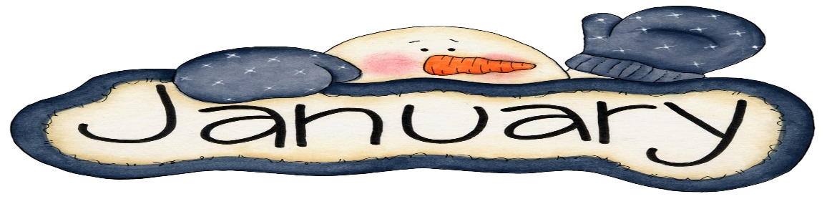
English Language Arts  Reading  This month our classes are continuing to read and think deeply about characters in the interpretation book club unit. Students are studying character’s traits, feeling, and motivations, as well as big themes expressed throughout the book.  **Please make sure your child is reading for 30 minutes every night and recording it on their reading log  Writing  During writing workshop students are working on writing literary essays. Students are learning how to write a strong thesis based on elements of different stories. They will support their thesis with different examples from the text such as mini stories, quotes, and lists. | Math  We will begin to learn all about factors and multiples which will lead us into our fraction unit.  Please continue to practice your multiplication facts and division strategies.  Word problems are an important part of our curriculum! We use the Problem Solving steps as a tool to help guide the students through the word problems  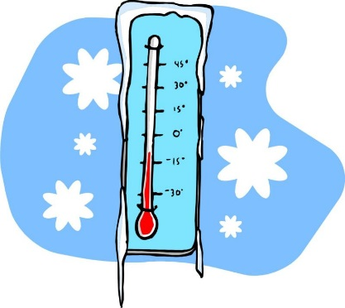
Content  Social Studies  Students will continue to study colonial times. This will lead us into our American Revolution unit.  Science  Students are continuing to learn about electrical grids. This will complete unit 1 of the Amplify curriculum and students will begin unit 2 in February. | Important Dates  Jan 2- STUDENTS RETURN TO SCHOOL  Jan 7- Trip to David A. Boody JHS  Jan 21- NO SCHOOL Martin Luther King Day  Jan 24- Bowling trip
Fourth Grade Newsletter

