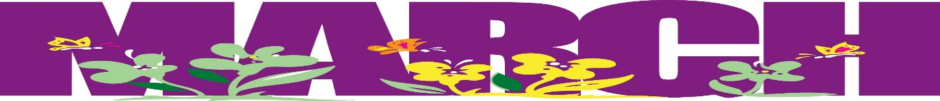
Fourth Grade Newsletter

English Language Arts  Reading  This month we are preparing the students for the ELA State exam. The students will be introduced to a variety of test taking strategies to help them succeed. The students will learn to read a passage closely by road mapping and annotating the text. They will learn how to answer different questions by understanding what kind of question it is and where in the text they can find the answer.  Writing  In continuance with reading, we are preparing the students to answer a short response by supporting the questions with two details. In the extended response, we will practice writing a four paragraph essay which includes an introduction and conclusion. | Math  We will continue our work with fractions. We are working on renaming improper fractions to mixed numbers; adding and subtraction fractions. Soon after that, we will introduce multiplying fractions.  Please continue to practice your multiplication facts and division strategies.  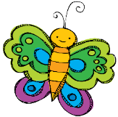  Word problems are an important part of our curriculum! We use the Problem Solving steps as a tool to help guide the students through the word problems
Content  Social Studies  Our next unit will focus on local and state government of the United States.  Science  In our new Unit- Vision and Light, students investigate the role that animal senses, primarily vision, play in survival as they try to understand a realistic fictional problem with a real organism.  Reminder: The NYS Fourth Grade Science Test is at the end of the year.  May 22nd- May 31st ,2019 -Performance Test  June 3rd, 2019 -Written section  Check website for past tests-  http://www.nysedregents.org/grade4/science/home.html | Important Dates  Mar 14- Parent Teacher Conference – Report Card Distributed  Half Day Schedule dismissal is 11:10am!  *Trip to Harbor Defense Museum – Dates vary for each class  