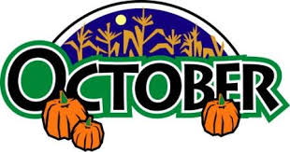

English Language Arts  Reading  This month our students will continue to study and interpret characters in a fictional story. The students have been observing and analyzing characters on a deeper level by creating charts, various graphic organizers, and growing ideas based on jots and textual evidence  After completing that study, we will move forward in our non-fiction unit of weather and natural disasters.  Writing  During our writing workshop, we will be completing our unit on fictional narratives by revising, editing, and publishing their realistic fiction stories.  In the middle of October we will introduce our essay writing unit. The students will learn how to develop a strong thesis and support it with various reasons. | Math  In our next math chapter, students will multiply two and three digit numbers by one digit numbers. Please practice the times tables with your child up to 12. Students will continue to practice problem solving skills by completing exemplar word problems
Content  Social Studies  We will continue discussing the geography of New York State and will be launching the Native American unit by mid-October.  Science  In Science students are studying in and out electricity. | Important Dates  Oct 8th- NO SCHOOL (Columbus Day)  Oct 19th – Fall Festival Dance  Oct 24th- Light Assembly  Oct 31st – Halloween – Ps177 March of Dimes Character Walk
Fourth Grade Newsletter

